**1**  INTRODUCTION

1.1 OVERVIEW

The banking industry world-wide is being transformed. The global forces for change include technological innovation; the deregulation of financial services at the national level and opening-up to international competition; and - equally important - changes in corporate behavior, such as growing disintermediation and increased emphasis on shareholder value. In addition, recent banking crises in Asia and Latin America have accentuated these pressures. The banking industries in central Europe and Latin America have also been transformed as a result of privatizations of state-owned banks that had dominated their banking systems in the past. In this project we are trying to analysis the bank related data and able to extract some insights from the data using Business Intelligence tools. To Extract the Insights from the data and put the data in the form of visualizations, Dashboards and Story we employed Tableau tool.

1.2 PURPOSE

Using this project one can analyze the asset graph of banks and can find proper

solution for asset variation.

**2** PROBLEM DEFINITION & DESIGN THINKING

2.1 EMPATHY MAP

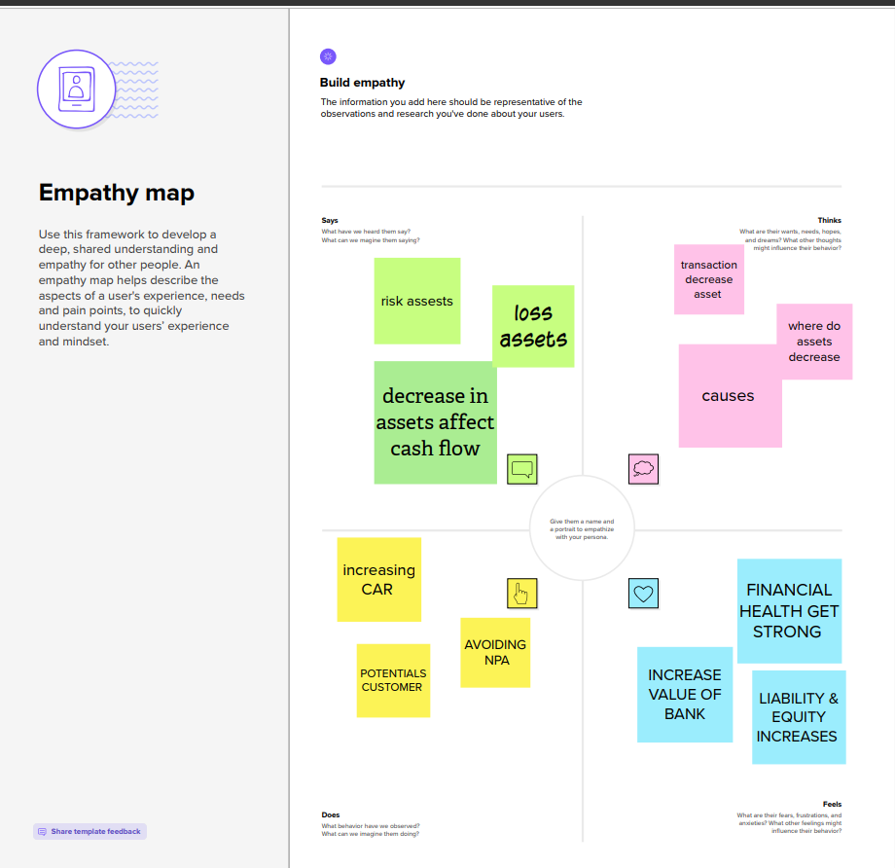

2.2 IDEATION & BRAINSTORMING MAP

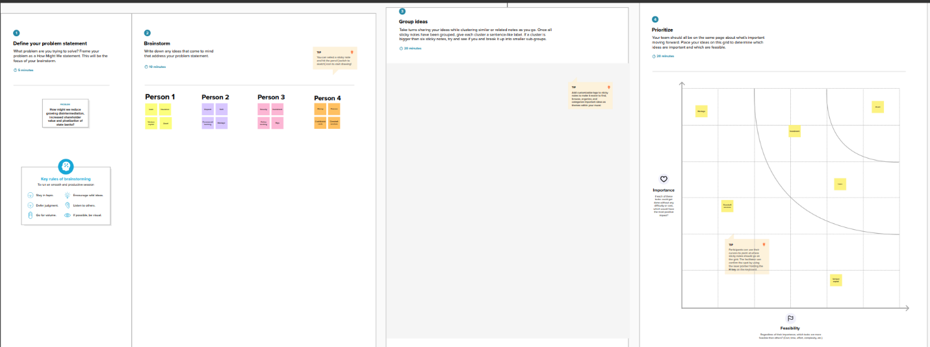

**3** RESULTS

DASHBOARD 1

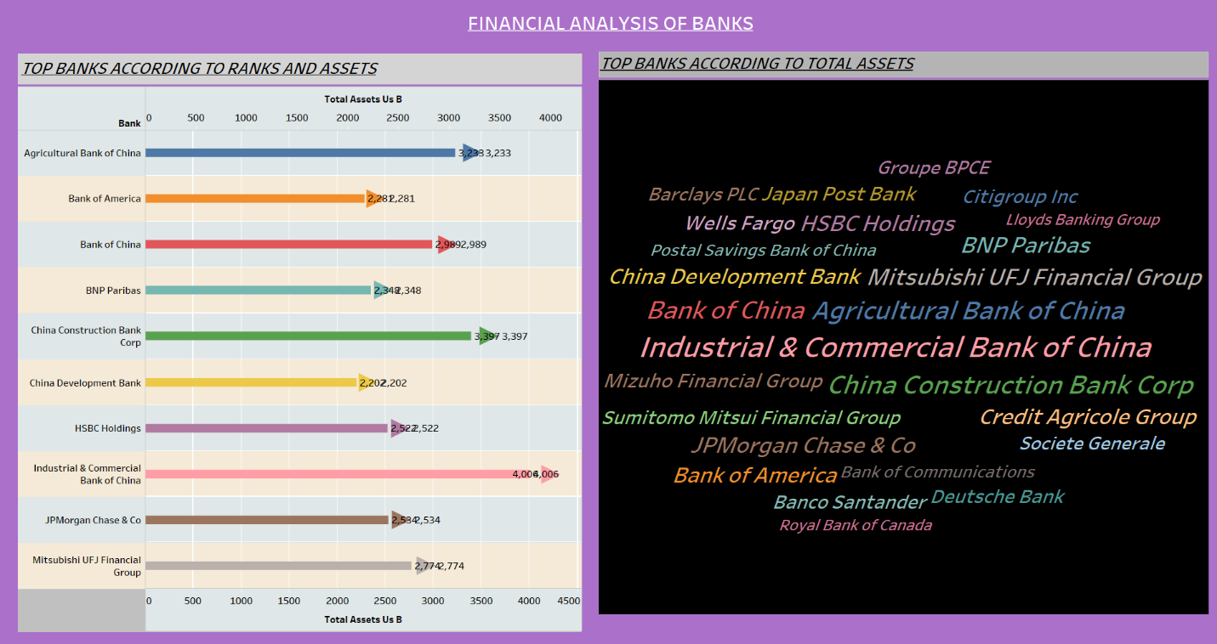

DASHBOARD 2

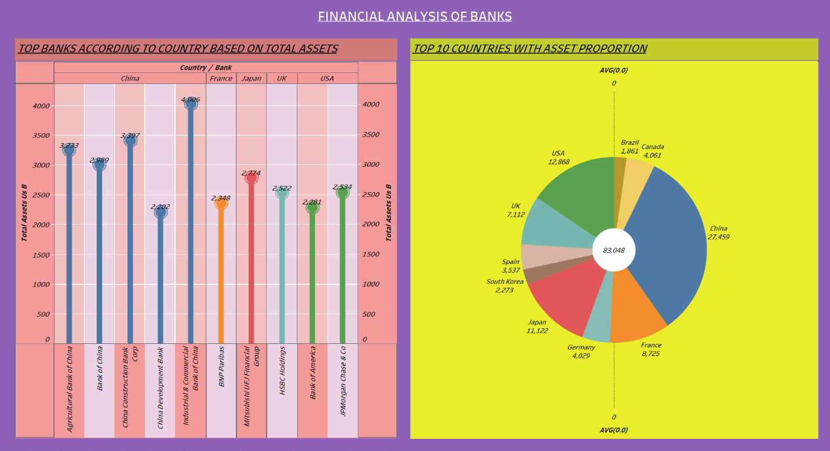

DASHBOARD 3

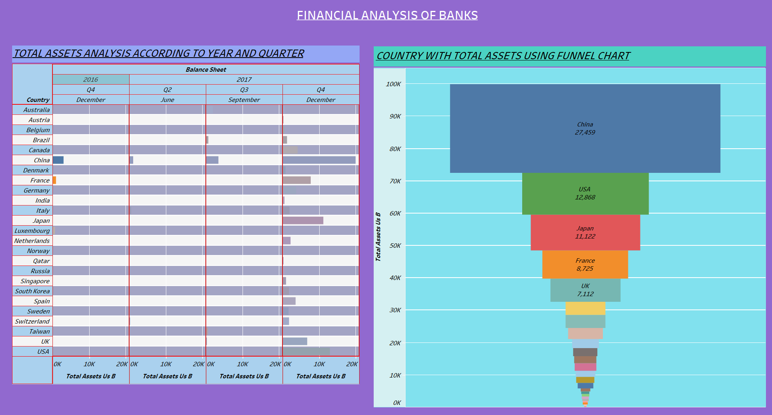

STORY

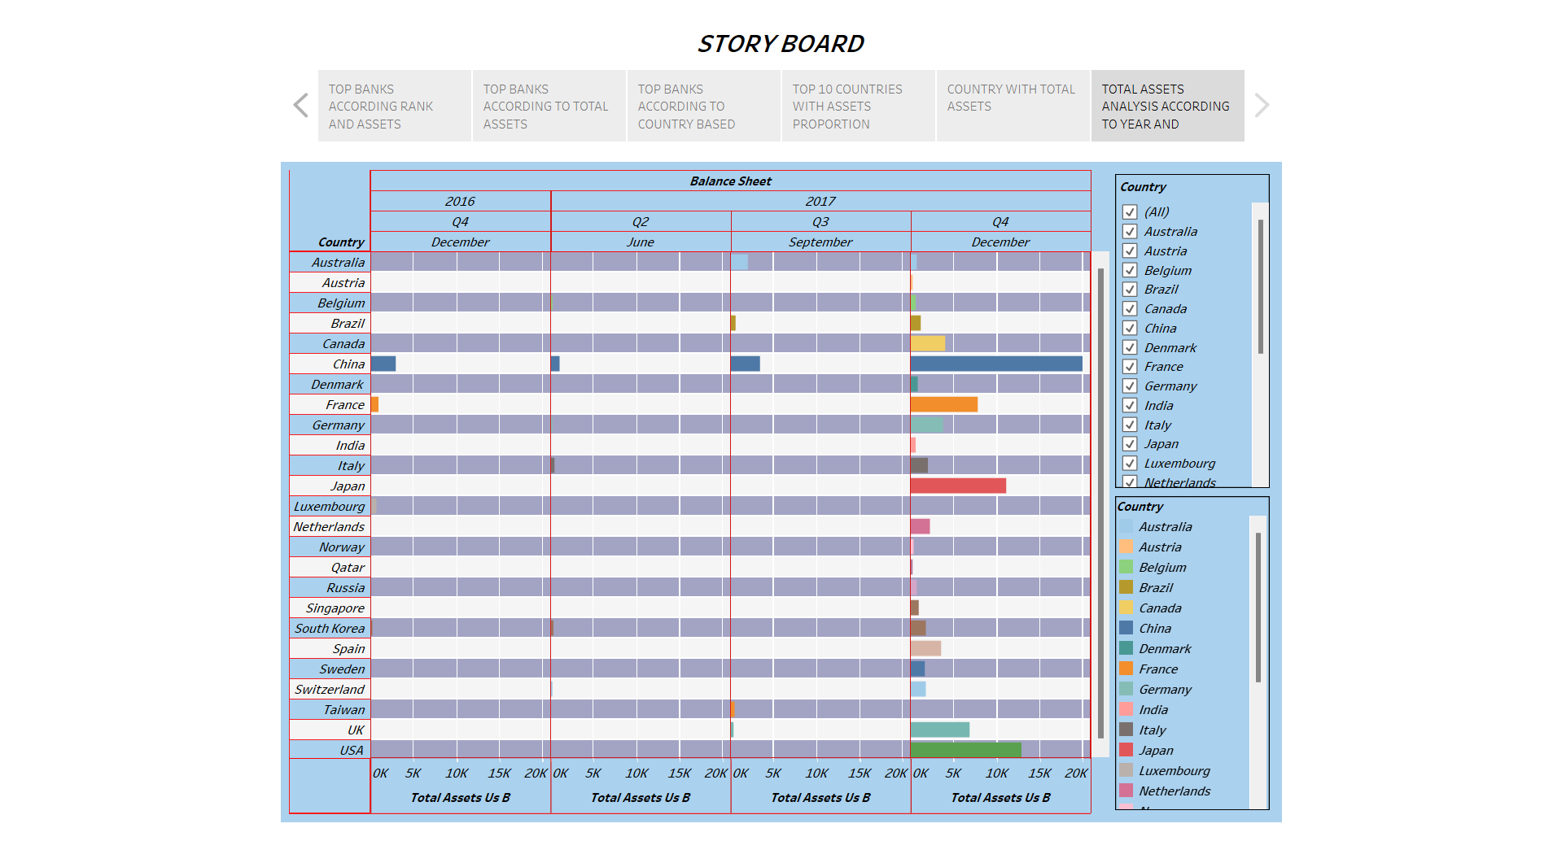

WEB APPLICATION

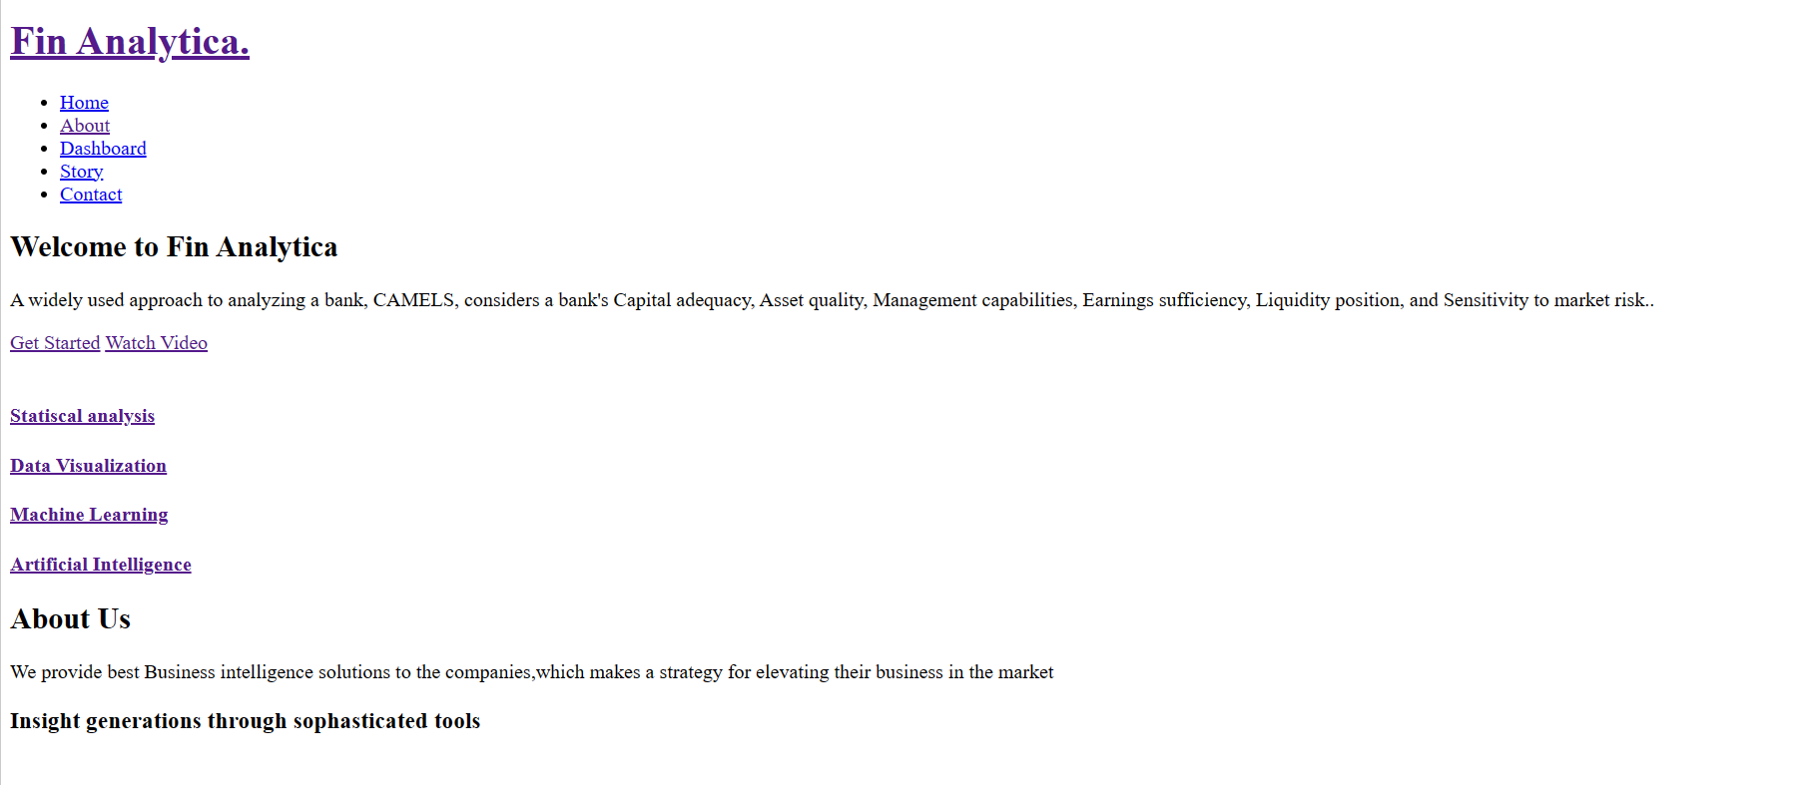

**4** ADVANTAGES AND DISADVANTAGES

* Shows the profitability and the financial position of banks.
* Creates accurate profit and loss reports.
* Assure shareholders and attract investors.
* May not increase in value while investors hold it.
* Generates a minimal rate of interest over a short time.
* Inflation affects cash and its equivalents.

**5** APPLICATIONS

In the field of banking sectors.

**6**  CONCLUSIONS

Through this project we understand that how to analyze a data and how to create graphs for

the data using tableau software. From the story which has been built in this project clearly shows

the performance of banks. This analysis helps us to identify underperformed banks and through

that information we can find a solution to increase its profit percentage. Finally, we studied the

application of data analytics in various fields.

**7** FUTURE SCOPE

* Improving the speed of tableau software.
* Allowing the permittable users to edit the workbooks.
* Increasing the license time for servers.
* SSSSGiving downloading option in tableau software.